29.73: a) 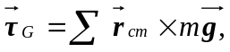 summed over each leg,
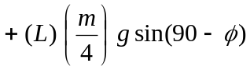
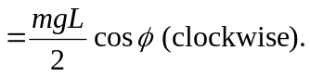
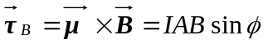(counterclockwise).
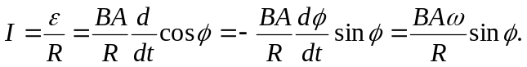 The current is going counterclockwise looking to the 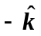 direction.

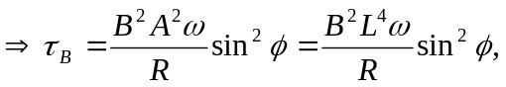
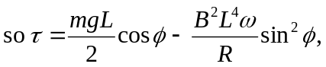 opposite to the direction of the rotation.
b) 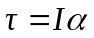( being the moment of inertia).
About this axis 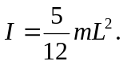
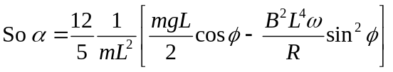
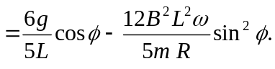
c) The magnetic torque slows down the fall (since it opposes the gravitational torque).
d) Some energy is lost through heat from the resistance of the loop.

